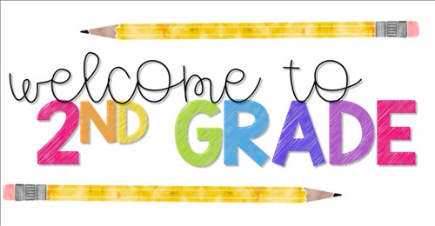

Welcome to Second Grade and the 2022-2023 school year! This year will be packed full of information and learning! You will be amazed at just how much your scholar will grow this year. Staying involved in your child‛s education is the key to a successful year. Engage your child in conversation about his/her day. Another way to stay involved is to check your scholars take home folder every night. They may be packed with school assignments, homework, projects, flyers, notices from the office, as well as notes from their teacher. As daunting as it may be, try to sort through them and read each one. They often contain important information and reminders.

# Academic Yearly Overview

In second grade, scholars will use individualized learning stations to master all academic content standards.

* **Math** *-* scholars will be required to identify numbers up to 120; understand and apply base ten using place value; fluently add and subtract up to 4-digit numbers; measurement, length, and time; and identify attributes of plane and solid shapes
* **Reading/Language Arts** – scholars will be required to master Second grade I-Ready sight words, read with fluency and accuracy while using decoding strategies
* **Writing** – participate in Writer‛s Workshop where they will learn the fundamentals of narrative, informational, and opinion writing compositions
* **Science** – scholars will learn about energy and motion, seasons of the year, shadows, moon phases, constellations, light and sound, life cycles of plants and animals, and basic needs of living things.
* **Social Studies-** scholars will learn about historical figures; Georgia: Georgia‛s first people, How Georgia Became a Colony, Becoming a Georgian; Production, Distribution, Consumption, and Scarcity; and Geography

# Assessments

* + Weekly Assessments for Math, Reading, Science, Social Studies
  + I-Ready

|  |  |
| --- | --- |
| Behavior Policy / Homework  All 2nd grade teachers will follow the same 7 Step Policy. This will be the basis for your child‛s conduct grade. Conduct does count toward a grade this year! Homework will be sent home nightly and will be included in the conduct grade. | 7 Step Policy   1. Nonverbal Warning – eye contact 2. Verbal Warning 3. Close proximity to teacher 4. Redirect behavior & a note home 5. Time out - IN classroom 6. Time out - OUT of classroom 7. Office Referral |

Remember to Check the School’s Website for Upcoming Important Dates.

<http://www.rcboe.org/bartonchapel>